**Project Design Phase-I**

**Solution Architecture**

|  |  |
| --- | --- |
| Date | 15 October 2022 |
| Team ID | PNT2022TMID09848 |
| Project Name | Project – classification of arrhythmia by using deep learning with 2-d ECG spectral image representation |
| Maximum Marks | 4 Marks |

**Solution Architecture:**

Solution architecture is a complex process – with many sub-processes - technology solutions. Its goals are to:

* Smart arrhythmetic of deep lerning refer to the intelligentization of ECG equipment.
* Provide specifications according to which the solution is defined, managed, and delivered.
* The complete Big data architecture includes computing devices.
* It combines Software products to make more intelligent use of from ECG spectrum.
* **Example - Solution Architecture Diagram:**

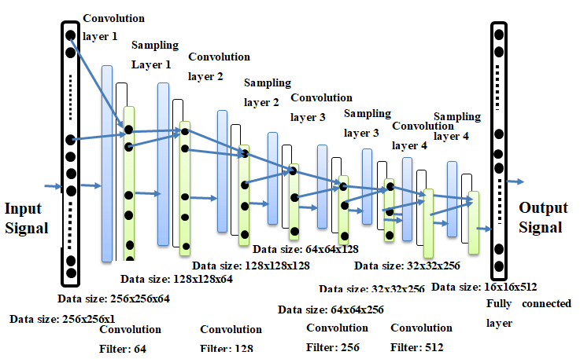

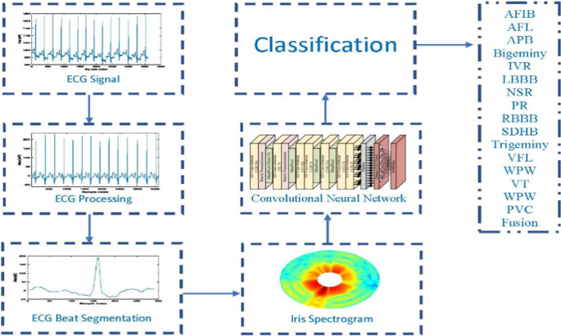

Figure 1: ECG sample application